解决XIRR与 XNPV*的问题
2007．10．15
概述
XNPV和XIRR如何工作，你可以参考本书第1和33章。这些函数解决了一个重要问题（当现金流是日期时间时的折现），但它们一个数字问题。
下面我们讨论这些问题。我们定义两个新函数NXIRR 和NXNPV来解决这些问题。新函数显示在本书文档的电子表中；如何在你的电子表插入这些函数，参见本书光盘中Getformula“添加”文档。

XNPV的问题：0折现率
XNPV, 如下所示, 只有正的折现率才能工作
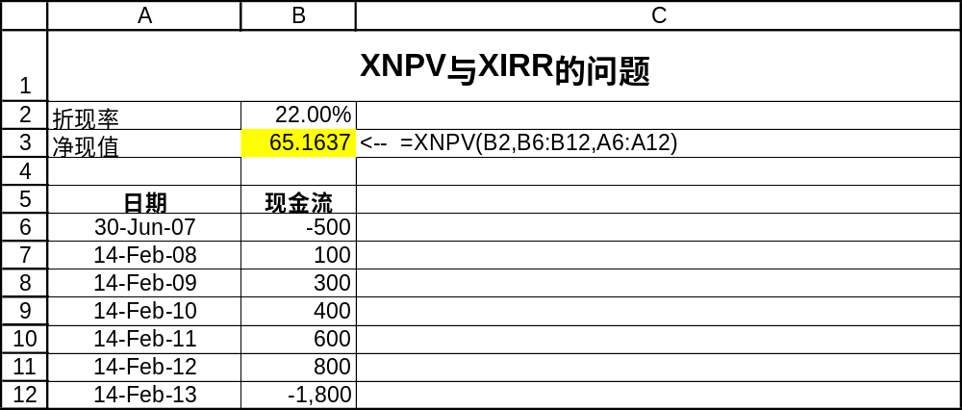
但是，0或负数折现率, XNPV 不工作:
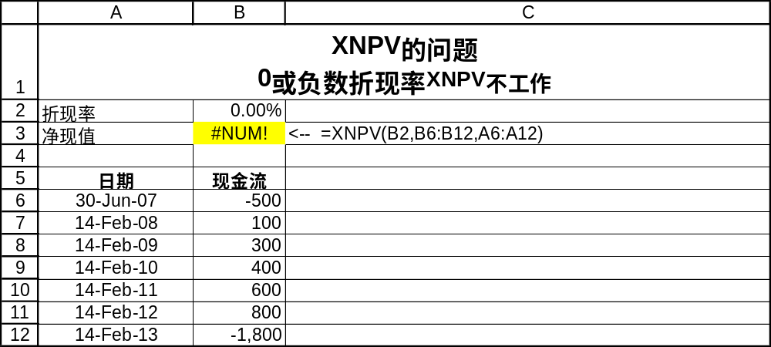
快速解决折现率为0的问题
针对折现率为0的问题, 快速解决方法是增加IF函数:
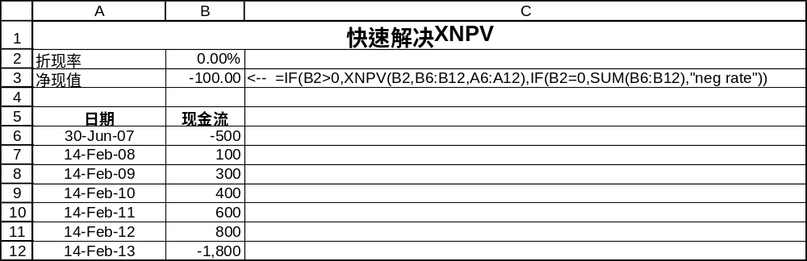
新函数NXNPV 是更好的解决方法。

问题: XIRR对两个IRR不工作
Guess 打开 XIRR不工作.见下面的问题：
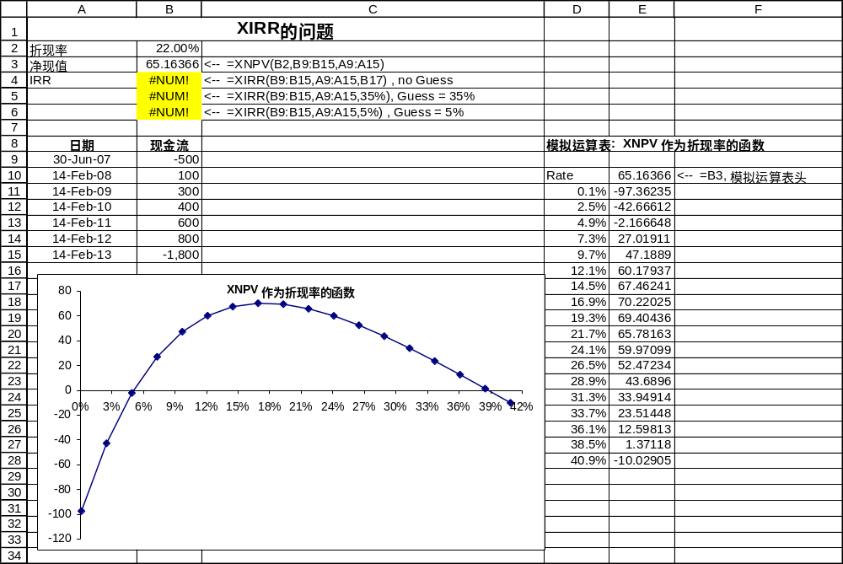
模拟运算表显示有两个 IRR( 约为5%和 39%). 但 XIRR函数没有识别出来( B4:B6).

XNPV 和 XIRR重新编程
在解决XNPV与XIRR的问题的电子表中，我们定义了两个新函数, NXNPV 和 NXIRR 解决该问题。
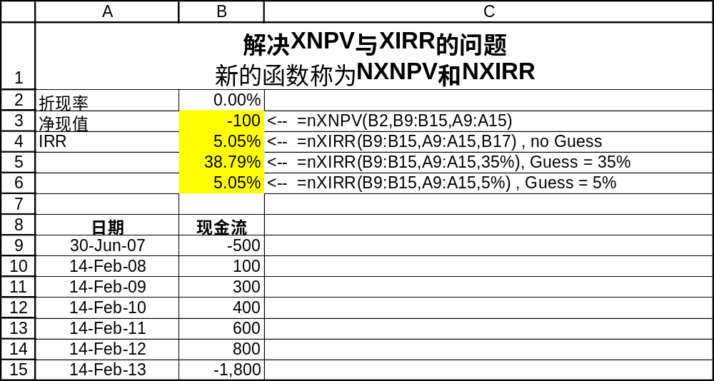
注意 B3，我们计算0折现率的 NPV。在B4:B6中我们说明了IRR的新的计算函数。
我们的 NXNPV 函数甚至对负的折现率也工作：
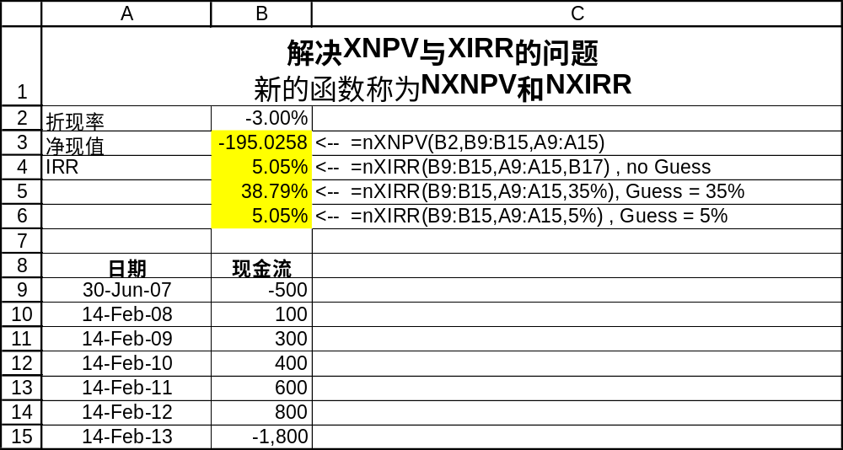
NXNP 与NXIRR编程
该 VBA代码(由Benjamin Czaczkes开发)是:
NXNPV
The function NXNPV also forms the basis of NXIRR below:
'NXNPV solves some problems in the XNPV function
'Written by Benjamin Czaczkes, summer 2007

Function nxnpv(Rate As Double, Values As Range, Dates As Range)
Dim Dsize As Integer
Dim Vsize As Integer
Dsize = Dates.Rows.Count
Vsize = Values.Rows.Count
If Dsize <> Vsize Then
nxnpv = CVErr(xlErrNum)
Exit Function
End If
Dim aValues
Dim aDates
Dim tempsum As Double
Dim r As Double
Dim dd As Long
Dim i As Integer
aValues = Values
aDates = Dates
r = 1 + Rate
tempsum = 0
dd = aDates(1, 1)
For i = 1 To Dsize
tempsum = tempsum + aValues(i, 1) / r ^ ((aDates(i, 1) - dd) / 365)
Next i
nxnpv = tempsum
End Function

For NXIRR
Our new function NXIRR uses a slightly different version of the time-dated NPV function (called ANNPV )
Private Function annpv(Rate As Double, aValues, aDates)
Dim Dsize As Integer
Dsize = UBound(aDates)
Dim tempsum As Double
Dim r As Double
Dim dd As Long
Dim i As Integer
r = 1 + Rate
tempsum = 0
dd = aDates(1, 1)
For i = 1 To Dsize
tempsum = tempsum + aValues(i, 1) / r ^ ((aDates(i, 1) - dd) / 365)
Next i
annpv = tempsum
End Function

'NXIRR solves some problems in the XIRR function
'It uses the ANNPV function above
'Written by Benjamin Czaczkes, summer 2007

Function NXIRR(Values As Range, Dates As Range, Optional Guess As Double = 0.1)
Const epsilon As Double = 0.0001
Dim D As Double
Dim V As Double
Dim oldV As Double
Dim r As Double
Dim Change As Boolean
Dim i As Integer
Dim StopNow As Boolean
Dim Dsize As Integer
Dim Vsize As Integer
Dsize = Dates.Rows.Count
Vsize = Values.Rows.Count
If Dsize <> Vsize Then
NXIRR = CVErr(xlErrNum)
Exit Function
End If
Dim aValues
Dim aDates
aValues = Values
aDates = Dates
r = Guess
D = 0.01
oldV = annpv(r, aValues, aDates)
StopNow = Abs(oldV) < epsilon
i = 1
Do Until StopNow
r = r + D
V = annpv(r, aValues, aDates)
Change = (V > oldV And V > 0) Or (V < oldV And V < 0)
If Change Then
D = -D * 0.5
End If
i = i + 1
StopNow = (i > 100) Or Abs(V) < epsilon
oldV = V
Loop
NXIRR = r
End Function

* This note, written by Simon Benninga (benninga@wharton.upenn.edu) and Benjamin Czaczkes (msbc@huji.ac.il ) accompanies Financial Modeling, 3rd edition. Although it is copyrighted, we authorize its replication, provided full name credit is given the authors.

